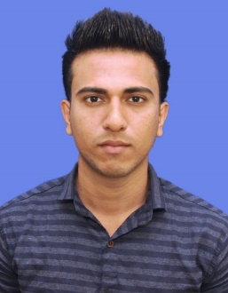

ABHISHEK HABE 7219414889 abhihabe007@gmail.com

# 

# CAREER OBJECTIVE

To obtain a challenging & responsible position in the area of information technology. where I want to use my technical skills, ability and dedication will be utilized to grow your company.

PROFESSIONAL TRAINING

• Undergone Software Testing Training in Qspiders Thane.

# IT PROFICIENCY

JAVA:

* TOKENS , DATATYPE , OPERATORS
* DECISION STATEMENTS ,LOOPS STATEMENTS
* METHOD OVERLOADING, RECURSION METHON
* CONSTRUCTOR, CONSTRUCTOR OVERLOADING, CONSTRUCTOR CHAINING

SQL:

* Good understanding of RDBMS concepts.
* Exposure to constraints (PK, FK, NOTNULL, UNQ, CHECK).
* Ability to write queries using joins, sub queries, grouping etc.

# ACADEMIC PROFILE

* B.E in Electrical engineering from A.C. patil collage of engineering,

Navi-mumbai.

* HSC from Maharashtra, R.C.F. college, Alibag with 65.08 %..
* SSC from Maharashtra, R.C.F. school,Alibag with 66.04%.

# ACADEMIC PROJECT

Project Name: “SMART TROLLEY WITH AUTOMATED BILLING” is submitted in fulfillment of the project work for the Bachelor’s degree in Electrical Engineering from University of Mumbai.

# TRAINING

* Completed Implant Training from ''J.kumar Infraprojects Ltd." Metro line 03,Kurla, Mumbai.
* Tunnel diameters can range from one meter (3.3.ft) (done with micro-TBMs) to 17.6 meters (58 ft) to date.
* The power needed for the TBM's is 20 mega volt amps (MVA) and will be provided at 33 kilovolts (kV).

## STRENGTHS

* Positive attitude
* Disciplined and Responsible

## PERSONAL DETAILS

* Name :- ABHISHEK HABE
* Father’s Name :- ANAND HABE
* Gender :- Male
* Phone no. :- 7058584657/7219414889
* Email id :- abhihabe007@gmail.com
* Languages known :- English, Marathi, Hindi
* Hobbies :- Reading books, playing football, swimming.
* Marital Status :- Single
* Nationality :- Indian

2